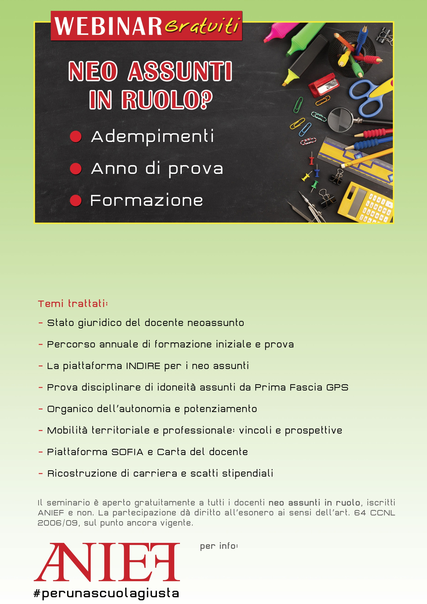

LINK Microsoft Teams

<https://teams.microsoft.com/l/meetup-join/19%3ameeting_NzE2MDIyZTktYzVkOS00ZDIyLTk5MGItMzMyNmM2N2Q4Njk2%40thread.v2/0?context=%7b%22Tid%22%3a%2258655386-5788-443b-84f0-715c466e2758%22%2c%22Oid%22%3a%2231a369f8-85f4-456b-b47a-17d01b324f90%22%7d>

**Napoli**–giovedì 4 novembreore 15-17

Relatore: Stefano Cavallini